

**Behaviour for Learning Policy**

*Aiming high, nurturing all.*

**Reviewed: October 2023**

**Ratified by Governors:** Previous policy ratified by governors November 2021. Updated policy due for renewal

Dec 22

At West Blatchington Primary and Nursery School we are dedicated to creating a happy, safe and inspiring learning environment based on mutual respect and trust for everyone in the school community. This is to enable all children to achieve their full potential and develop as respectful and responsible citizens.

**Aims of the policy:**

* To promote positive behaviours for learning
* To promote a positive ethos in the school by encouraging a shared understanding through the school’s vision
* To support children in becoming positive, responsible and independent members of the school community through building their self-esteem.
* To support children in understanding what respect looks like and how to show respect for others
* To promote an environment where everyone has the ability to express how they are feeling
* To promote good relationships so that people can work together with the common purpose of helping everyone to learn and succeed
* To ensure that everyone takes responsibility for their actions and choices and are aware of how their behaviour impacts on others around them
* To provide a clear outline of the structure of positive behaviour strategies used in both the classroom and around the school

**Responsibility and Rights:**

***We believe that everyone has a part to play.***

**Everyone has the right in our school to learn, be respected, to be safe and to be listened to.**

**Responsibility of the child:**

* To do their best
* To follow the class contract
* To ask for help when needed
* To listen when others are speaking
* To follow instructions from all members of staff and other adults within the school e.g. Governors, people from external organisations
* To be involved in resolving issues fairly
* To allow others the opportunity to learn
* To dress in accordance with the school uniform policy to reflect school pride and a sense of belonging

**Responsibility of the Governors:**

* To support the school in the implementation of the policy
* To regularly review the policy and offer advice to the head teacher on behaviour issues if required
* To adhere to the core expectations for staff (see separate document entitled Core Expectations for Staff)

**Responsibility of the Staff:**

* Staff will be fully prepared for lessons so that children’s learning is maximised to the full
* Model professional behaviour towards each other, pupils and their families at all times
* Ensure that all members of the school community understand the need for all children to feel emotionally and physically safe, and to respond in line with the safeguarding policy and associated procedures
* That unacceptable behaviour is challenged by all, using the Restorative Approach where appropriate
* To be consistent in their approach to ensure children are clear about what is expected of them

**Responsibility of the Parent:**

* To talk to the class teacher or other member of staff constructively if concerns arise
* To ensure their child attends regularly and on time
* To talk to their child about their school day
* To be supportive of school values

**It is the whole school community’s responsibility to ensure the principles of the behaviour policy are supported.**

**Consistency of practice**

* All staff who work at the school, governors and parents have access to a copy of the policy
* Newly appointed staff will receive a copy of the policy in their induction pack and have an induction session with the Inclusion Manager. This is now a requirement in line with the amended Keeping Children Safe in Education document and is a formal part of the induction process
* The policy is discussed regularly in phase meetings and staff meetings to ensure consistency
* Children causing concern are discussed during regularly scheduled meetings and Senior Leadership meetings as appropriate
* Non-teaching staff are included in appropriate information sharing
* All staff to receive regular training and support on behaviour management
* Whole school routines to be monitored by Senior Leadership Team

***We recognise and respect individual needs***

The behaviour policy recognises the individual needs of everyone and the aim of the policy is to promote an inclusive school community.

***We are proud to be part of our school community***

**Behaviour for learning: Learning Heroes:**

To promote the skills required to develop ‘good behaviour for learning’, pupils are introduced to five Learning Heroes. The Learning heroes are Resilient, Relating, Resourceful, Reflective and Responsible. The learning powers associated with the five heroes underpin our everyday practice and equip all pupils as learners. Pupils are empowered to take calculated risks particular to their age and ability, learn from one another and from their mistakes and be enabled to see this as a necessary and important part of the learning process.

In order to develop an effective learning culture throughout our school, the learning behaviours are embedded in everyday practice and are used when giving praise and motivation.

**Uniform and jewellery:**

All children are expected to wear full school uniform every day unless previously agreed for special days or trips. The uniform consists of:

* Grey or black trousers or skirts
* White polo shirt or shirt
* Red sweatshirt, jumper, cardigan or fleece
* Sensible and smart footwear including boots, girls shoes should be flat shoes or boots, (please note that this does not include brightly coloured trainers or open toed sandals)

The PE uniform consists of:

* White T-shirt
* Red shorts
* Track suit bottoms (in winter)
* Plimsolls or trainers

The only jewellery that is allowed are stud earrings for health and safety reasons. We also do not allow children to wear make-up to school and parents and carers will be consulted if this is an issue.

**Movement around the school:**

* Children need to walk on the left, in single file, and are expected to move around the school safely and quietly
* Teachers collect classes from the playground / field and enter the school through the appropriate door. Support staff should help facilitate a quiet line into the school building

**Assemblies:**

* Assemblies need to start promptly so children are not sitting for long periods of time waiting
* Children to be seated in line order by the class teacher
* Class teachers should stay in the hall until the assembly begins
* The expectation is that children enter and leave the hall quietly
* Children who do not make good choices in assembly are to be noted by the adults present and added to CPOMs so that frequency can be tracked for individuals and classes.

**Behaviour at Break and Lunchtimes:**

During break and lunch times we provide structured activities to support positive playtimes.

* The playground is zoned and each zone is allocated an activity. The activities may include: parachute games, ball games, skipping, football, circle games, etc
* The support staff on duty are expected to participate and engage children in games on the playground
* A group of upper Key Stage 2 children are trained as Playmakers to lead games with younger children in order to promote active, fun and social lunchtimes
* Support staff use Restorative Justice language to facilitate children resolving disagreements on the play ground
* Tokens are awarded to individual children demonstrating positive behaviour choices. These are shared with the class teacher at the end of break so that they can be added to the class totals for each colour team. ‘Stickers to success’ may also be awarded for whole class positive playtimes.
* Support staff are able to facilitate time to ‘rethink’ where the child has to sit with an adult to talk through positive choices. This is up to a maximum of 5 minutes and will relate to the learning ladder, when on rethink children are encouraged to think about the Just Right tower and what they need to do to get back into the green zone.
* For any significant incidents on the playground a member of the Senior Leadership Team (SLT) or the inclusion learning mentor needs to be informed, as well as class teachers and details entered on to CPOMs.
* Teachers establish with their class any additional expectations in relation to wet play activities. Wet playtime activities are available for the MDSAs to supervise. These are kept in each classroom.

***We work together in a safe, happy and nurturing environment***

**Positive Behaviour Management- Rewards and Consequences:**

As a school we encourage the children to recognise and reflect on the importance of making good behaviour choices. This will help children understand and take responsibility for their own behaviour. Pupils can expect to be recognised for positive choices and where appropriate, be given one of the rewards the school offers. All of these are clearly outlined to the children at the beginning of the academic year and are regularly revisited and celebrated.

**Motivational activities:**

* Learning hero certificates given at the end of each term
* Token for children who have been recognised to have gone above and beyond on that day
* Verbal praise from a member of staff
* Celebration assemblies: jigsaw pieces linked to the learning heroes, displayed to celebrate individual achievement
* Written comments on children’s work
* Acknowledgement from another member of staff, including SLT
* Public praise (anonymised) in the school newsletter
* ‘Stickers to Success’ for whole class

Child

**Proactive intervention**

* Modelling and promoting positive behaviour for learning and use visuals to remind children about expectations
* Class contract
* Placement and use of peripheral vision in order to pick up on low level behaviours
* Quiet discussion with the child to remind them about teachers expectations
* Use of Restorative Justice (RJ) language to resolve issues.

**Consequences**

* Being placed on rethink on the learning ladder. All behaviour that reaches this point is recorded on CPOMS
* Reset (see reset flow diagram in appendix A)
* Work that is not completed in class due to choices will be sent home to finish
* Removal from the class by Senior Leadership Team or nurture team if behaviour poses a risk to themselves or others
* Internal suspensions for half or whole day. This could be in another class in the same Key Stage or in the other Key Stage as appropriate. This will be agreed by Senior Leadership Team or the Inclusion mentor and communicated with parents or carers
* Fixed term suspensions are agreed by the Head teacher or a member of the Senior Leadership Team acting in that role in the Head teacher’s absence.
* A parent / carer being asked to come into school to work alongside their child to complete work
* Linking in with PCO ( Police communications officer)
* Permanent exclusions

|  |  |  |
| --- | --- | --- |
| **Low level behaviour:**  Talking and shouting out  Unkind comments  Verbally challenging agreed code of conduct  Running in the school building | **Behaviour:**  Any persistence of low level behaviour  Arguments at play and lunch  Distracting others  Lying  Physical  Defiance  Aggressive language  Inappropriate use of technology and social media – including use of language; using inappropriate images | **Significant behaviour:**  Fighting  Persistent conflict (including online)  Prejudice based incident which may include a sigificant peer on peer abuse issue  Refusal to accept a consequence |

All behaviour incidents are managed on an individual basis which allows for the most appropriate consequence to be given in order to move the situation forward and allow the child to reflect on the choices made. In the case of high level behaviour many factors could be involved which is reflected in the consequences.

**Restorative Justice:**

Restorative approaches refer to a range of methods and strategies which can be put in place to resolve relationship-damaging incidents once they occur as well as preventing such incidents from occurring. Our school values run alongside restorative principles in the prevention of harm as well as in the resolution of conflict. Restorative approaches are in place and used to improve relationships and diminish harmful conflict in our school. They are also used to address issues such as bullying, classroom disruption and absence.

Restorative justice is the process that emphasises the importance of feelings and their effect on relationships. Restorative Circles and conferences enable those who have been harmed to convey the impact of the harm to those responsible and those responsible acknowledge this impact. All involved make the decisions on what is needed in order to take steps to put it right.

**Behaviour: West Blatchington’s Learning Ladder:**

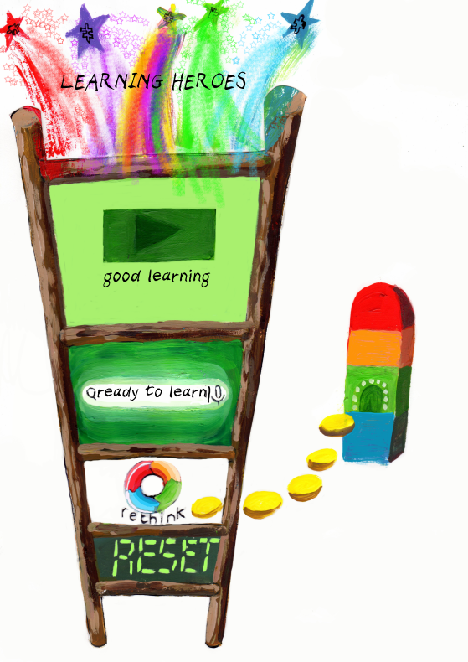

Our school behaviour for learning system has a neutral starting point with every child beginning the day on ‘ready to learn’. The children can then move to ‘good learning’, which, with teacher praise, indicates to the child that they are doing well. If the child’s learning behaviour is such that they are working above and beyond they can then move to ‘learning hero’.

For this they would receive a token for their team.

However, if a child is having difficulties regulating themselves, they will be moved to ‘rethink’. They will then be directed to the Just Right tower and their personal profile/class tool box. By moving, the ladder reinforces that they need to change their learning behaviour using a positive choice. It also allows the child time to get back on track using Just Right strategies.

If this opportunity is not taken and the behaviour continues to fall below school expectations, the child will be moved to ‘reset’. At this point, the teacher is looking for them to correct their behaviour and move back to being ‘ready to learn’. The adult will co- regulate with the child, explaining exactly what needs to change and a strategy to help them achieve this.

During reflection time, the child talks to the teacher about what the expectations are for the next lesson, using visual aids as a prompt. This is recorded on CPOMS under the appropriate category.

**Reporting and Recording of behaviour**

**CPOMS:**

Every member of staff has access to our school monitoring system CPOMS (Child Protection Online Monitoring System). Behaviour incidents are inputted to CPOMS using different categories. Every term the Nurture team works with the SENCo to collate all of the information and a behaviour report is published. From this the class teachers and Learning and Inclusion mentor are able to monitor patterns in behaviour across the school and identify strategies to further improve behaviour for learning.

The termly report to SLT uses the data on CPOMS and focuses on the children that have been placed on the behaviour framework from level 1 upwards. Each child’s overall behaviour for learning is looked at and measured against the previous half term.

If a behaviour incident also involves a safeguarding issue, relevant information will be passed on to the Designated Safeguarding Lead who will take appropriate action in line with the school’s Safeguarding and Child protection policy.

**Individual behaviour plans**

As specified in the behaviour framework guidance, all children on level two will have personal support plans. These will be drawn up with input from class teachers, parents and the pupil. These plans will be subject to regular review.

* Level 2 - Every half term
* Level 3-4 - Every 2-3 weeks
* Level 5 - Weekly

Once reviewed, an email will be sent to all key staff ensuring that they have the most current document.

At stage 1 of the behaviour framework (see appendix E) when a child has a growing number of behaviour incidents the class teacher will contact the parents. If a child moves into stage 2 a letter or phone call to the parents to arrange a meeting with the class teacher and Inclusion mentor to discuss the behaviour and set behaviour targets. If the behaviour incidents continue a meeting is arranged with a member of the Senior Leadership Team and a Behaviour support plan is put in place. Where appropriate, at this time or during any stage, a referral may be made to outside agencies to access additional support; this could include Brighton and Hove Inclusion Support Service (BHISS- SEMH), CAMHS or any other relevant agency.

**On-Call system:**

On-Call is used for dysregulated behaviour in class, which poses a risk to the individual or others in the class. If there is danger to others then the class should be removed for their safety. In this instance, a member of the nurture team should be called for and if they are unavailable a member of Senior Leadership Team must be contacted. A succinct summary of events should be relayed at this point. The on-call staff member will come to the classroom immediately. The adult present should calmly inform the on-call staff member which child is involved**.** The behaviour should not be discussed in front of the child, class or other members of staff (unless necessary). The Learning and Inclusion mentor/ the member of staff on call, will inform the Head teacher / Assistant Head teacher of this incident.

**Physical intervention:**

Staff at West Blatchington Primary and Nursery School will always use a wide range of strategies to defuse any difficult behaviour.

The school provides regular training for staff in physical intervention (and alternatives to it) along the lines of the Maybo approach. There are named members of staff that have been trained in Maybo physical intervention. During training, staff are made aware of statutory guidance. A register is kept by both the Business Manager and the Designated Safeguarding Lead of staff who are Maybo trained.

Physical interventions with pupils should only occur as a last resort where

* There is a risk of serious harm to individuals, (including the pupil concerned) or an imminent risk of significant damage to property
* Verbal calming techniques and other methods of de-escalation have not resolved the situation

Where physical intervention has been used, the incident is recorded on CPOMS and further details are provided on the physical intervention form and shared with parents. These are saved on the management drive. We provide appropriate conflict resolution and/or restorative justice dependent on the pupils’ needs and the needs of the parties involved in any such incidents.

Any pupil where it has been identified that physical intervention may need to be used as a last resort, will have this included in their Personal Support Plan. This will detail the MAYBO intervention methods and will be shared with the pupil, staff and parent/carer.

**Exclusion:**

This is only used for an extreme behaviour incident. At West Blatchington Primary and Nursery School, we take incidences of violence, bullying (See anti bullying policy including online bullying), racism and prejudice based language very seriously.

**Fixed term exclusions**:

The time period for a temporary exclusion is determined by the Head teacher, and usually falls within 1-5 days.If an exclusion extends to a 6th day a reciprocal arrangement exists between both Hangleton Primary school and Goldstone Primary School, where pupils will attend accompanied by a member of staff and work is provided.

If the fixed term exclusion is at home, work will be arranged for the child to complete and the parents must agree to not allow their child to be outside of the home for the duration of the exclusion

All cases will be reviewed and judged on an individual basis, and decisions made in consultation between the Head teacher/ Assistant Head teacher and class teacher and Learning and Inclusion mentor. Only the Head teacher or the appointed person in the absence of the head may exclude a child. It is the responsibility of the Head teacher/ Assistant teacher to complete the appropriate paper work and report it to the Local Authority and parents. A reintegration meeting will be convened with the Head teacher, child and parent/carer on the child’s return to school. The Inclusion mentor may be invited to attend. Parents will be informed of this by letter. The Governing Body is informed of all exclusions.

**Permanent exclusions** are very rare, they are in accordance with Brighton and Hove Policy (a copy is available from the school office).

The school will always endeavour to keep a child in the education system and exclusion, fixed term or permanent, is always a last resort.

**Bullying & Prejudice based incident:**

This policy should be read in conjunction with the Anti Bullying Policy as well.

**Reference to other policies:**

Teaching and learning

Health and safety

Inclusion and SEND

PSHCE

Equality

Child Protection and Safeguarding

Disability

SMSC

[LA exclusion policy](http://www.brighton-hove.gov.uk/content/children-and-education/schools/school-exclusions)

[Governments Physical restraint policy](http://webarchive.nationalarchives.gov.uk/20130401151715/https:/www.education.gov.uk/publications/eOrderingDownload/Use%20of%20Reasonable%20Force%20-%20Advice%20for%20Head%20teachers%20staff%20and%20governing%20bodies.pdf)

Anti bullying policy

**Monitoring the policy:**

The policy will be reviewed annually and ratified by the full Governing body.

Appendix A:

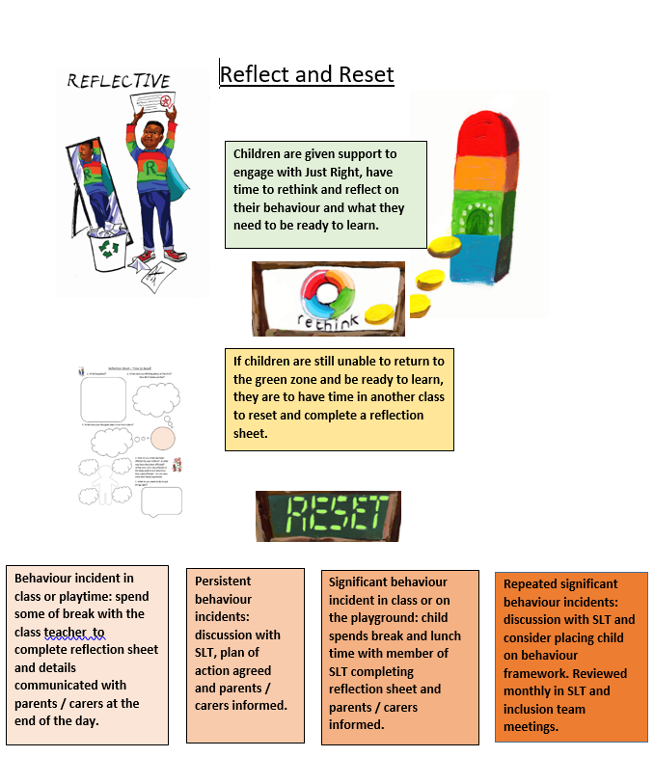

Appendix B:

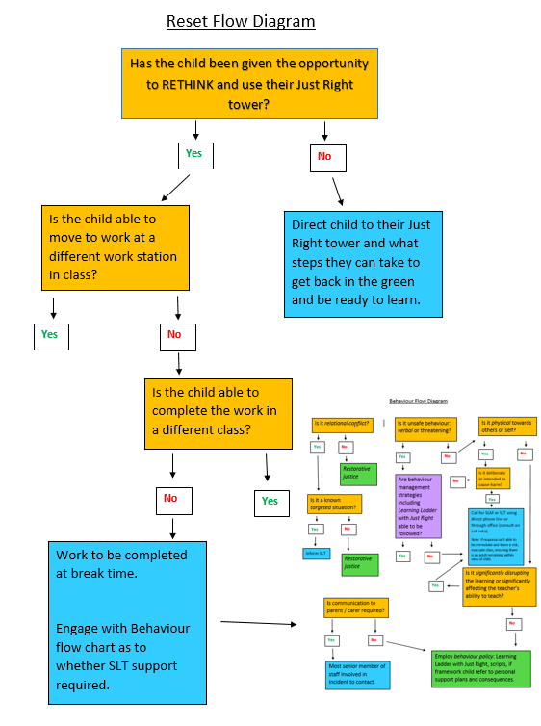

Appendix C:

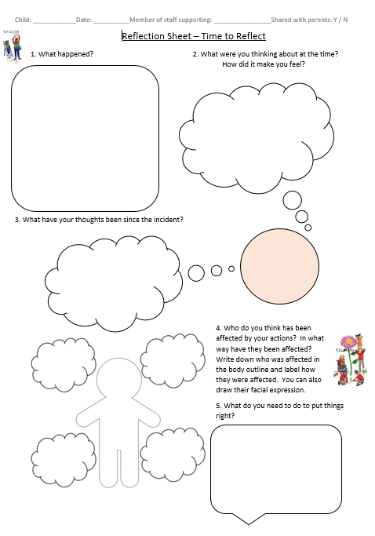

Appendix D:

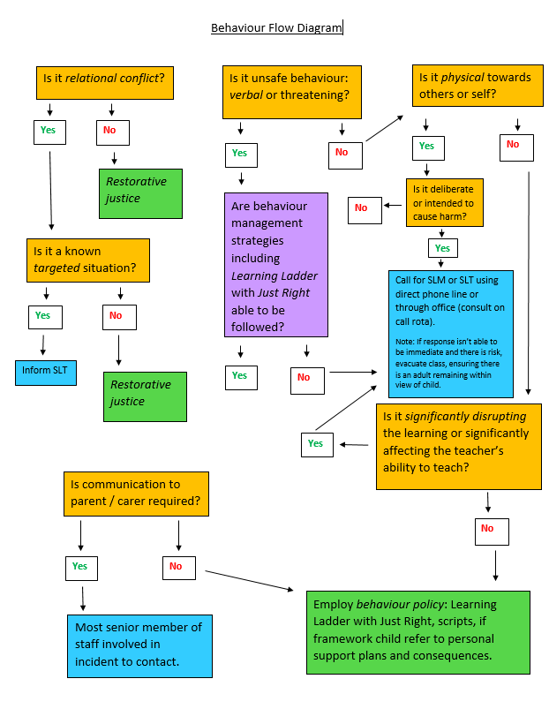

Appendix E:

Behaviour Framework

|  |  |  |  |
| --- | --- | --- | --- |
| **Levels of Need** | **Possible Behaviours** | **School Interventions** | **School Actions** |
| **Level 1: Causing Concern**  **Action:**  **Monitor & Assess** - Log behaviour and carry out early assessment of need   * Identified lack of progress and attainment * Poor attendance - 90%? * BESD presentations – beginning to infringe school policy * Incidences of poor social communication and integration difficulties | * Lateness and absence * Non-engagement with learning * Not completing tasks * Not able to keep to expected behaviour expectations * Incidents of Low level disruption – calling out/noise making/not following instructions logged on CPOMS * Withdrawal and or social integration problems * SEMH concerns that result in an INCO team referral | * Regular discussions with other school staff – School Children Causing Concern * Establishing expectations with pupil – early identification of concerns and need * Parent/Carer meeting with class teacher * Clear, consistent behaviour policy in place (class charter, rules, scripts etc.) * Celebrating individual successes – catching the good, peer recognition and involvement e.g. Roles and Responsibilities, Spotting talents * Inco referral completed * Investigation into learning – Pupil Progress meetings discuss lack of progress, barriers to learning and appropriate agency support e.g. BHISS, SALT, EMAS * Individual visual timetable * Use of Buddies, alternative lunchtime clubs, match right child to right adult * Current and up to date Staff Training E.g. on De-escalation/Conflict resolution and Physical intervention/Restraint where appropriate * Classroom/ Environment modifications e.g. workstations , visual prompts * Identify learning style * Sharing positives with identified adult | 1.Meet with parents/carers – Build a picture of the child  2. Evidence of Quality First Teaching ( by HT/Ofsted)  3. Peer teaching support & SLT Observations and Action planning  4.Regular discussions with appropriate staff around ‘Children Causing Concern’  5.Class environment modifications e.g. work stations/visual timetables  6 INCO referral  7.Auditory/visual/sensory needs analysis  8.Use of Nurture Intervention  9.Friendship/Social communication groups |
| **Levels of Need** | **Possible Behaviours** | **School Interventions** | **School Actions** |
| **Level 2: First Response**  **Action:**  **Plan & Record** - Action plan and Build a picture of the Child and their needs. Keep formal records, Children Causing Concern reports, class learning and behaviour logs that are forwarded to Head teacher/SENCO and Early help   * Continued poor progress and attainment * Patterns of non-attendance – 90%? * BESD presentations – patterns and frequency of poor behaviour increasing * Continued poor social integration | * Persistent lateness or absence * Frequent refusal and lack of engagement * Regularly disrupting lessons * Increased levels of conflict – arguing with staff and pupils/ swearing/physical incidents * Frequent attention needy behaviours * Ongoing social integration problems e.g. Teasing, stealing spoiling game playing etc. | * Add to Beh Framework grid / report individuals incidents to SLT half termly Via CPOMS * Early Help –BHISS & Family Support * Further investigation into social, family and learning needs * Parent/carer meeting with SLT/SENCO * Home/school agreement plan * Individual personal support plan – clear rewards and consequences (adaptation of main policy if necessary) * Draw up individual profile of child, their needs, trigger points, ‘soothers’, key adults etc. so all adults supporting them understand the needs of the individual -including Supply staff.- child voice driven * Intervention group e.g. Nurture Support, Friendship and social communication group etc. * Triple P parent support * Create safe spaces around the school * Develop shared scripts for **all** staff to use (Regular and continued staff training appropriate to the needs of the children and the roles of the adults) | 1.Meet with parents/carers – Relationship building  2.Early Help Assessment  3.Individual Personal Support Plan (PSB)AND/OR SEND action plan  4.Use of internal isolation as required  5.BHISS- SEMH referral  6.Use of Learning Mentor/key worker  7.Wellbeing referral |
| **Level 3: Specialist Support**  **Action:**  **Refer** - Review school action plan of support and refer for specialist (multi-agency ) advice and investigation   * Increasingly poor behaviour - may lead to internal and FT exclusions * Lack of response to support and intervention * Personalised support and behaviour plan required * Regular involvement of SLT required | * Persistent lateness or absence * Behaviour is a serious barrier to learning * Regular refusal * Often in ‘fight/flight/freeze mode’ * Needs high levels of individual support * Greater levels of conflict – overreacting to small incidents * Temper outbursts * Use of abusive and threatening language * Bullying behaviours * Leaves classroom at will/hides/puts themselves in unsafe situations | * Counsellor (child & Parent/Carer) * Personalised learning programme – bespoke approach * Use of Breakfast clubs and After school clubs as incentives and provide alternative positive hooks to the school environment * Referral for FDFF for services * EP consultation – school and Parent/carer * Provide individual provision map on what the child has /hasn’t received to establish next steps * Personal support plan reviewed regularly | 1.Meet with parents/carers – keep informed, alleviate anxiety and outline next steps    2.Use of INA or other individual adult support  3.Refer FDFF  4.BHISS- EP referral  5. Professionals Meeting    6.Personalised Curriculum and/or Timetable  7.BHISS- SEMH individual pupil support and supervision for teaching staff  8 .Use ‘buddy’ or partner school in place of FT exclusion |
| **Level 4: Intensive Support**  **Action:**  **Do & Review** - Put in place specialist recommendations and review impact and progress   * Embedded patterns of non-attendance * Emerging patterns of fixed term exclusions * Persistent lack of response to school policy and expectation * Intense level of support required in order to access school at all | * High SLT involvement * Regular outbursts towards staff and peers * Relationships with key adults deteriorates * Frequent bouts of destructive behaviours – throwing furniture and objects in temper rages * Works to own agenda * Unpredictable and unsafe behaviour patterns – putting themselves and others at risk * Spits at staff and peers * Self-harms or threatens to hurt themselves * Steals on a regular basis * Damages school property (brings dangerous items into school) * Runs off site * Behaviour impacts on wider school community e.g. Police involvement is required | * INA attached to child for class/playground or both * Personal Support plan and Profile reviewed weekly * Creative, personalised and integrated timetables (working to the child’s strengths) * Investigate other additional settings to improve school engagement and raise self-esteem e.g. forest schools, local sports/ social clubs * Ongoing multi agency meetings – specialist reviews and supporting next steps e.g. Managed Moves * Withdrawal into Nurture/Calm Space if appropriate to sustain school attendance, educational opportunity and social integration – prior to slow return and re-integration into school routines * Draw up Risk assessments around child’s needs and levels of provision required over the course of a school day – share with all staff and adults working with the child * Review evidence – initiate ECHP | 1.Meet with parents/carers – help to make informed choices for their child’s education and well-being  2.Ensure curriculum and school routine works  3.Refer to BAP  4. CAMHS referral  5.Managed Move to another school (not automatic referral to the PRU) |
| **Levels of Need** |  | **Possible Behaviours** | **School Interventions** |
| **Level 5: Critical Need**  **Consultation with LA**   * All previous interventions have been unsuccessful * Grave concerns from school and outside agencies of suitability of current school setting * Behaviour leads to critical incidences | * No improvement after considerable and sustained input and support from all agencies * Ongoing serious and unsafe levels of behaviour risking harm to both themselves and others * Staff and pupils regularly hurt – requiring Health and safety incident reports * Very little of any academic progress is being made | * Intensive multi-agency action planning meeting * Parent/carer involvement in appropriate placement discussion * Bespoke individual specialised provision required – LA to advise | 1.PRU/ Specialist provision may be required |