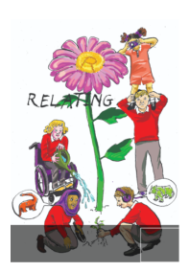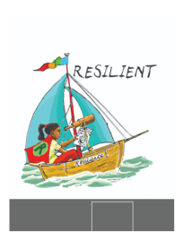School Council Minutes

Date: 04/06/24

Points

1. End of term staff vs children competition

Feedback from classes – what they would like:

Rugby

Basketball III Year 3, 5 and 6.

Netball

Hockey II Year 2 and Year 4

1. Lost property

Time to sort out lost property.

1. Summer fair stall

Not enough school council attending to run a stall.

BEFORE THE NEXT MEETING, PLEASE DISCUSS WITH YOUR CLASS:

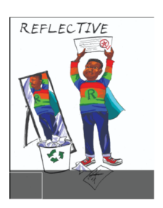The staff versus children competition will be basketball. Please choose 1 girl and 1 boy from years 3-6 and 1 child from Falcons. Posters and 1 cheerleading chant per class – make within classes.

Make notes in your school council book.

