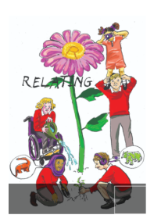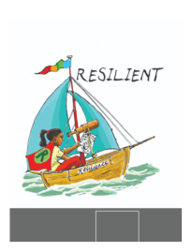School Council Minutes

Date: 14/05/24

Points

1. Summer term activities

Would we like to something for the summer fair? What?

Penalties

Sponge the staff

Scooter race

Sell the lost property!

1. End of term staff vs children competition

What event would your classes like? Collect ideas and feedback

1. Lost property

There is too much lost property. Can we think about how to stop this getting so large? School council to sort out next session.

BEFORE THE NEXT MEETING, PLEASE DISCUSS WITH YOUR CLASS:

What end of term activity your class would like with staff – not football as we did that last year! Choose from rugby, basketball, netball, hockey. Collect any lost property in or near classes and bring it next meeting.

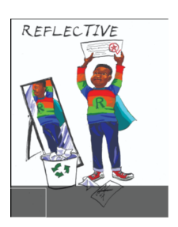Make notes in your school council book.

