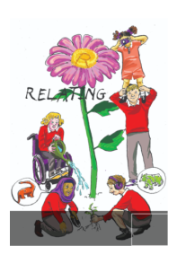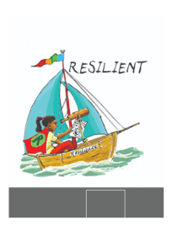School Council Minutes

Date: 30/01/24

Points

1. Safe and Happy survey

Feedback from Mr Brentnall. Most children know what to do if they have a worry. Most said they felt adults listen to them. Most children enjoy their lessons. Need to think about ‘do you like school?’. Need to talk to classes about 3 things we like and 3 things that would make school even better. Most year groups feel really safe. Year 1, 4 and Falcons – is there anything we could be doing to make you feel more safe? Bullying – Year 2 and year 5 to have the opportunity to do more work to understand this.

1. Safe and well-being feedback

All classes should be talking about mental health and well-being. Before the end of term, we would like feedback about mental health and well-being. This could be posters, photos, comments from children – its up to each class what they would like to provide.

1. Ways to raise money

Feedback from classes:

Cake and toy sale with lemonade and ice cream, Sponsored silence,

Make toys to sell, Pay to party,

1. Easter activity

Bunny hunt – we will be launching the draw the best bunny competition and using them to design a bunny hunt. We will do this at our next meeting.

BEFORE THE NEXT MEETING, PLEASE DISCUSS WITH YOUR CLASS:

Each class to say 3 things we like about school and 3 things to make it better.

Explain that we would like some feedback about health and well-being after classes have done their mental health and well-being lessons.

Make notes in your school council book.

