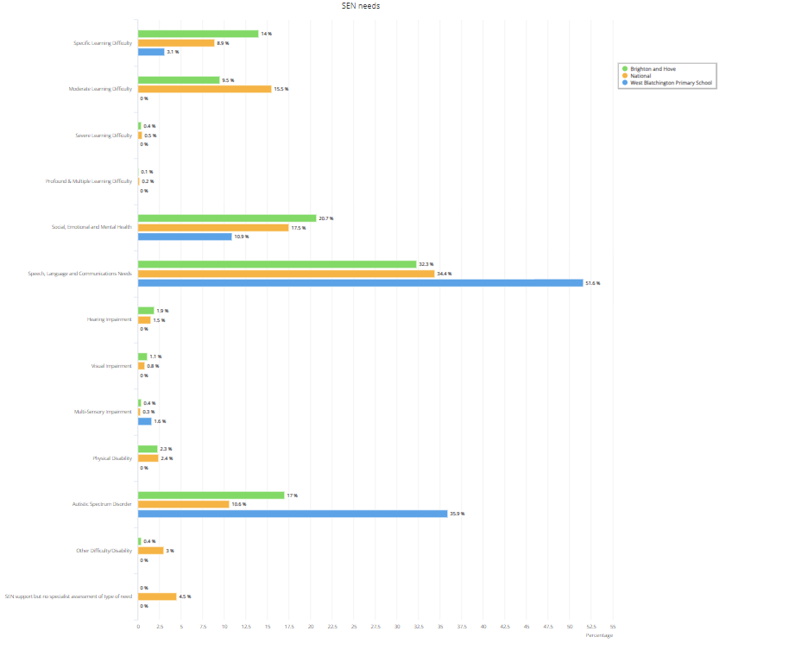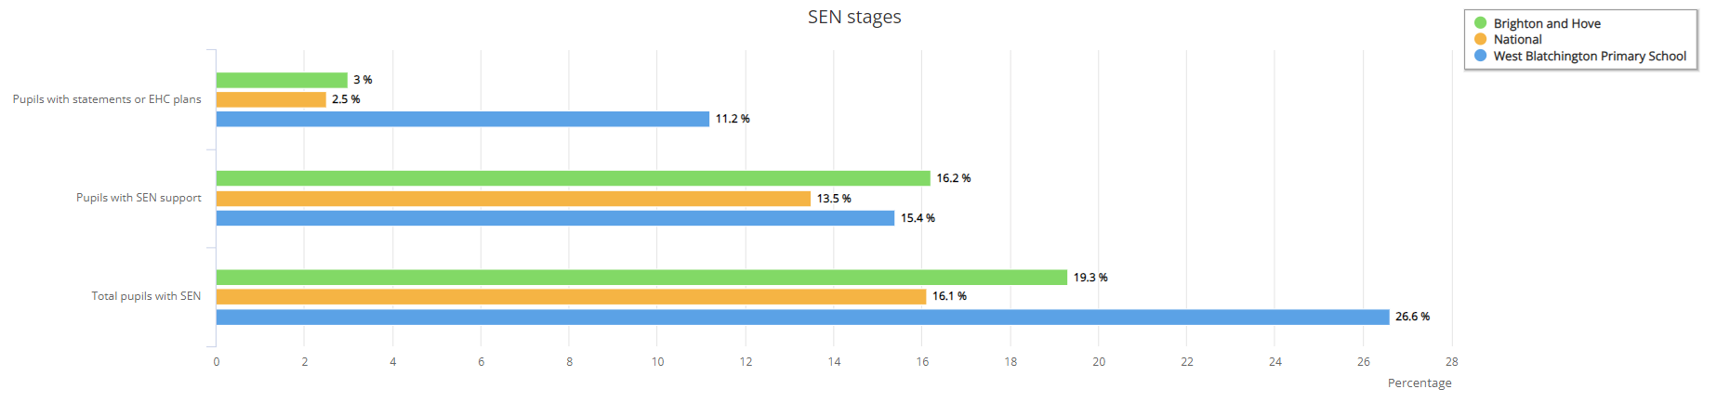

|  |  |  |  |  |  |  |  |
| --- | --- | --- | --- | --- | --- | --- | --- |
|  | Reception Year 1 | Year 1 | Year 2 | Year 3 | Year 4 | Year 5 | Year 6 |
| SEN | 1 | 4 | 7 | 12 | 12 | 15 | 13 |
| E | 1 | 1 | 4 | 2 | 6 | 5 | 8 |
| K | 0 | 3 | 3 | 10 | 6 | 10 | 5 |

West Blatchington Primary and Nursery School

SEND Information Report

2023-2024



Contents

Our school’s approach to supporting pupils with SEND 3

Supporting different kinds of SEND 4

Key staff 5

Roles and Responsibilities in the School for children with SEND 6

Securing and deploying expertise 7

Identifying and assessing pupils with SEND 8

Consulting with parents/carers and children 10

Progressing towards outcomes 10

Involving key stakeholders 11

Transition support 11

Teaching approach 13

Adaptations to the curriculum and learning environment 13

Inclusivity in activities 13

Supporting emotional and social development 14

Evaluating effectiveness 15

Handling complaints 15

Local Offer 15

# Our school’s approach to supporting pupils with SEND

At West Blatchington Primary and Nursery School, we are committed to giving all our children every opportunity to achieve success and reach their potential. We do this by taking account of pupils’ varied life experiences and needs. We offer a broad and balanced curriculum and have high expectations for all children. The achievement and well-being of every child matters to us and inclusion is the responsibility of every person within the school community.

We refer to the Term “Special Educational Needs” if a child:

Requires additional or different support beyond what is normally delivered in the classroom to their peers

Has a disability which prevents or hinders them from accessing education, facilities or services normally provided by the school.

SEND is categorised under four broad areas of need

# Supporting different kinds of SEND

Support across the four broad areas of SEND is tailored for each child 

Communication and Interaction - A child may have Speech, Language and Communication needs when they have difficulty in saying what they want, understanding what is being said to them or they do not understand or use the social rules of communication. Children with a diagnosis of Autism are also identified as having communication and interaction needs.



Cognition and Learning - This broadly describes where children’s learning is not at the level expected for their age due to learning difficulties.



Social, Emotional and Mental Health - Children may experience a wide range of social and emotional difficulties which manifest themselves in many ways. These may include becoming isolated and withdrawn, as well as displaying distressed behaviour.



Sensory and/or Physical Needs - Some children require special educational provision because they have a disability which prevents or hinders them from making use of the educational facilities generally provided. Some children also have identified sensory, physical or medical needs that require additional support such as a hearing or visual impairment, sensory dysregulation.

# Key staff

|  |  |  |
| --- | --- | --- |
| **Name of SENDCO** | **Email address** | **Phone number** |
| Alison Colbran  Working days Wednesday, Thursday and Friday | alisoncolbran@wblatch.brighton-hove.sch.uk | 01273 770777 |
| **Name of Welfare Manager** | **Email address** | **Phone number** |
| Natalie Bellis | nataliebellis@wblatch.brighton-hove.sch.uk | 01273 770777 |
| **Name of Headteacher** | **Email address** | **Phone number** |
| Russell Brentnall | russellbrentnall@wblatch.brighton-hove.sch.uk | 01273 770777 |
| **Name of SEND/Inclusion Governor** | **Email address** | **Phone number** |
| Simon Sharron | simonsharron@wblatch.brighton-hove.sch.uk | 01273 770777 |

# Roles and Responsibilities in the School for children with SEND

|  |  |
| --- | --- |
| **Role** | **Responsibility** |
| **Class Teacher** | **To provide good quality first teaching by:**  Considering the views of parents/carers and pupils  Identifying and assessing individual need and tracking progress  Planning and delivering a challenging and differentiated curriculum which ensures the progress of all children  Using prior knowledge as a starting point for learning  Adapting teaching strategies and techniques to sensitively meet the needs of all learners  Creating a classroom environment where all pupils understand expectations and know where to find support  Creating a classroom atmosphere which encourages and values the contributions of all children  Identifying, planning for and delivering/organising provision for children needing extra support  Devising personalised SEN Support and targets, with support from the SENDCo  Implementing the advice from outside agencies to support the learning and progress for identified children |
| **Teaching**  **Assistants/ Specialist**  **Support Staff** | **To support the work of the class teacher by:**  Working directly with children who have SEND by supporting them within the classroom and targeting areas of focus from their SEN Support Plans  Teaching and supporting the use of strategies which encourage independence.  Working in partnership with the class teacher by contributing to planning and feeding back on progress towards individual targets and learning outcomes  Supporting identified children, under the direction of the class teacher/SENDCo, through interventions appropriate to their need |
| **SENDCo** | Monitoring the progress of all children across the school in collaboration with the Senior Leadership Team  Regularly reviewing the impact of provision against pupil outcomes  Facilitating training for support staff where appropriate  Providing SEND advice for all staff  Working in partnership with pupils and parents/carers to improve outcomes  Liaising with a range of agencies and ensuring the implementation of support programmes |
| **Headteacher** | The day to day management of all aspects of the school including the provision made for children with Special Educational Needs and Disabilities (SEND)  Ensuring the school complies with all statutory requirements  Building a school ethos of inclusive practice |
| **Governor for SEND/Inclusion** | Supporting the school to develop the quality, and evaluate the impact, of provision for children with SEND |

# Securing and deploying expertise

We recognise the importance of the National Award for Special Educational Needs Accreditation and the SENDCo is working towards this. The SENDCo actively engages in a range of opportunities to share best practice and keep abreast of current, local and national initiatives and policy to support children with SEND.

The Pioneer Academy is invested in inclusive practice and high-quality teaching and learning experiences for children with SEND. Our TPA SEND Toolkit has been devised to support school staff with planning for and supporting children with SEND across a variety of needs. Headteachers, SENDCos and school staff can also access support and advice from the central team via the Head of SEND or Head of Nurture and Support Staff.

The school also seeks advice and guidance from local special schools and other relevant agencies to help school staff develop provision for children who have the most complex needs. Specialised training for teachers and support staff is an important part of ensuring that they have the appropriate skills and knowledge to support the needs of children with SEND.

This is the specialist training that we have secured in the last academic year for our staff to further their expertise and development:

|  |  |  |  |
| --- | --- | --- | --- |
| **Staff role** | **Area of Expertise** | **Level** | **Deployed to** |
| Teaching Assistants | Speech and Language | Basic MAKATON | Whole school |

# Identifying and assessing pupils with SEND

We know when a pupil needs help if:

* Concerns are raised by parents/carers, external agencies, teachers, the child’s previous school or the child themselves, regarding slower than expected levels of progress or a child’s starting point.
* Screening, such as that completed on entry or as a result of a concern being raised, indicates gap in knowledge and/or skills.
* Whole school tracking of attainment outcomes indicates lack of expected rate of progress.
* Observation of the pupil indicates that they have additional needs.

When children have an identified Special Educational Need or Disability (SEND) before they start our school, we work with the people who already know them and use the information already available to identify what their needs will be in our school setting and how we can support them.

We encourage parents/carers who have concerns about their child to discuss these with the child’s class teacher in the first instance, by asking for a meeting with them. The class teacher may then speak with the SENDCo to seek further advice

If a class teacher is concerned about a child, they will discuss their concerns with the parents/carers and agree ways of working together to support the child. Where a child continues to struggle to make progress, despite support matched to the child’s need, the class teacher and/or SENDCo will discuss with the parents/carers Special Educational Needs support which can then be put in place.

There are two levels of support:

SEN Support:

The school, together with the parents/carers, implement a support plan based on the need(s) of the child. Targets will be identified with actions needed and planned outcomes. The work is undertaken at school level.

Education Health Care Plan (EHCP):

An Education, Health and Care plan is for children and young people aged up to 25 who need more support than is available through SEN support. EHC plans identify educational, health and social needs and set out the additional support required to meet those needs. The Local Authority has overall responsibility for these plans but the school and parents/carers are both involved in the monitoring and review of provision.

In deciding whether to make special education provision to support educational, social, physical or emotional needs, we:

* Work in partnership with parents/carers and children
* Consult with relevant external agencies, e.g. Speech and Language Therapy, Educational Psychology, Occupational Therapy
* Use a variety of assessment tools & materials
* Conduct observations

Graduated Approach – Assess, Plan, Do, Review

We use a graduated approach to identify needs and assess the impact of support. Four types of action should be taken to ensure effective support. A continuous cycle will be used to provide children with additional support and includes the following:

Plan

Do

Review

Assess

Children who are receiving SEN Support will have an SENSP (SEN Support Plan – formerly known as an IEP – Individual Education Plan) and this will include targets and strategies to help them overcome difficulties. This will take into account the child’s strengths as well as areas of difficulties. It will identify ways in which parents/carers can help children at home. Identified additional provision will then be carried out until the next review. These targets will be reviewed each term and parents/carers will be invited to discuss this at parent/teacher consultations or at a separate meeting if necessary. Both parents/carers and children will be invited to contribute to reviewing progress against the targets. In some cases, it may be necessary to increase or change the nature and level of support to help a child to make progress. This may involve seeking help and advice from a range of specialist agencies such as the Educational Psychologist or Speech and Language Service. A referral for support from an outside agency will only be made with the consent of parents/carers.

Children who have an Education, Health and Care Plan (EHCP) will have an additional annual review of their progress which involves parents/carers and all adults involved in the child’s education.

Class teachers meet with the SENDCo each term to monitor the progress of every child in the school and identify children who may need additional support in one or more areas. The SENDCo coordinates the provision and will let parents/carers know in writing if a child would benefit from some additional support – please note that this may include children who do not have SEND but would make better progress with a short-term intervention. The SENDCo monitors the progress of each intervention provision every term and adapts the support as necessary. The impact and effectiveness of provision is discussed with the Governor for SEND and reported to the Governing Board.

We use a secure online platform (Edukey) to hold our information on SEN Support Plans and Provision. This can be accessed by parents/carers at any time and ensures that they always have access to up-to-date information regarding their child.

# Consulting with parents/carers and children

Parents and carers are involved in discussions regarding their child’s needs and provision from the earliest possible opportunity. This process usually starts with the class teacher.

If parents/carers are concerned about their child and would like to talk to someone we ask that they contact their class teacher who will be happy to meet with them. A child’s class teacher knows them well and will be able to talk about what support the child already receives and suggest ways of enhancing their learning and development.

If, having done this, parents/carers feel that they would like to discuss concerns further then we ask that they contact the SENDCo via email or through the school office to arrange a meeting.

Parents and carers are invited termly to a 10-minute parent-teacher meeting. The meeting will involve reviewing a child’s progress, attainment, needs and interests in more detail and to assess how well we are all doing in meeting their needs. Annual reports provide more information about progress and parents/carers will always receive copies of reports from outside agencies.

For children with an Education Health Care plan (EHCP) long term aims and specific objectives are reviewed in a statutory annual meeting with the child, their family, class teacher, SENDCo and any outside professionals supporting the child.

Targets are shared with the children and their views are sought termly for their “Pupil Passport”. This gives the team supporting the child an overview of their strengths, interests, support preferences and aspirations.

Children are also invited to attend the parent/teacher consultations to discuss their progress and targets.

# Progressing towards outcomes

Teachers are responsible and accountable for the progress and development of all the pupils in their class. They use on-going assessments throughout the year to review the rates of progress children make. The SENDCO attends every Pupil Progress Review meeting which take place every term. The meetings give the SENCO an accurate picture of the rates of progress and levels of attainment being made by the children. When considering the rates of progress of children with additional needs, the SENDCO will work with the class teacher to implement support for the children. Strategies used by the school to assess children include:

* On-going assessment to track the performance of pupils in class on a daily basis in order to monitor any progress made towards SEND targets
* End of term assessments to establish levels of attainment and rates of progress made by the child
* Class tracking systems to report on progress of all children

# Involving key stakeholders

The school works with a number of specialist agencies to seek advice and support to ensure that the needs of all children are fully understood and met. These include, but are not limited to:

* [BHISS](https://www.brighton-hove.gov.uk/directories/special-educational-needs-and-disability-send-support/brighton-hove-inclusion-support-service-bhiss) – Brighton and Hove Inclusion Support Service
* [CAMHS](https://www.brighton-hove.gov.uk/families-children-and-learning/childrens-services/child-and-adolescent-mental-health-services-camhs) (Child and Adolescent Mental Health Service)
* [Family Hubs](https://www.brighton-hove.gov.uk/families-children-and-learning/childrens-services/what-family-hubs-offer) (Children and Family Services)
* [Community Paediatrician](https://www.sussexcommunity.nhs.uk/services/community-paediatrics-brighton-and-hove-children-and-families/108946) ( Seaside View)
* [Local Authority Children’s Services](https://www.brighton-hove.gov.uk/families-children-and-learning/childrens-services/childrens-services) (Health and Social Care)
* Education Welfare Service
* Educational Psychologist
* [Hearing Impairment and Vision Impairment Service](https://www.brighton-hove.gov.uk/directories/special-educational-needs-and-disability-send-support/brighton-hove-inclusion-support-5) – Sensory Needs Support
* [Occupational Therapy](https://www.sussexcommunity.nhs.uk/services/occupational-therapy-for-children-brighton-and-hove-children-and-families/109017)
* [Parent Partnership](https://amazesussex.org.uk/wp-content/uploads/2013/03/parent_partnership_charter.pdf) – Amaze
* [School Nurse](https://www.sussexcommunity.nhs.uk/services/healthy-child-programme-hcp-health-visitors-and-school-nursing/528135)
* [Special School Outreach Support](https://www.brighton-hove.gov.uk/special-educational-needs-and-disabilities/hillside-outreach-and-inclusion-service) – Hillside Outreach and Inclusion
* [Speech and Language Therapy](https://www.sussexcommunity.nhs.uk/services/speech-and-language-therapy-for-children-brighton-and-hove-children-and-families/109060)
* [Virtual School for Children in Care and Previously in Care](https://www.brighton-hove.gov.uk/virtual-school-children-care-and-previously-care)

# Transition support

A number of strategies are in place to enable effective pupils’ transition. These include:

On entry:

A planned introduction programme is delivered in the Summer term to support transfer for children starting school in September.

Parent/carers are invited to a meeting at the school and are provided with a range of information to support them in enabling their child to settle into the school routine.

The SENDCo is available to meet with all new parents of children who are known to have SEND to allow concerns to be raised and solutions to any perceived challenges to be located prior to entry.

If children are transferring from another setting, the previous school records will be requested immediately and a meeting set up with parents/carers to identify and reduce any concerns.

Transition to a new class:

When moving between classes a transition meeting will take place between the current teacher and the new teacher.

As required, there will be opportunities for children to visit their new class and meet key staff.

A transition photo book or social story may be used, if appropriate, to assist with this change.

Parents and carers have an opportunity to meet the new class teacher in the Summer term.

Transition to a new school:

The SENDCo will contact the new schools’ SENDCos and share information about special arrangements and support that has been given to help children progress.

We will ensure that all records are passed on as soon as possible and within 5 working days of being notified that a child has enrolled at a new school.

Transition to secondary school:

When moving to secondary school, the SENDCo will liaise with all of the receiving schools, regarding any child with additional needs.

Successful arrangements and interventions currently used to support children can be shared with the receiving school and additional visits to the new setting may be planned to help children become familiar with the setting and to reduce any anxieties.

The annual review in Y5 for pupils with an EHCP begins the process where parents are supported to make decisions regarding secondary school choice.

Parents will be encouraged to consider options for the next phase of education and the school will involve outside agencies, as appropriate, to ensure information provided is comprehensive but accessible.

Accompanied visits to other providers may be arranged as appropriate.

If a child has an EHCP the secondary school staff will be invited to the annual review in year 6.

# 

# Teaching approach

All children receive high quality teaching, differentiated to their individual needs. For children with additional needs this could mean that they are given a slightly different task or given different strategies/equipment to complete the task. Some children may require support or guidance from the class teacher or a teaching assistant as part of a small group, paired work or on an individual basis. Our teachers are skilled and supported to adapt teaching to meet the needs of each class. Their planning considers the individual needs and requirements of all children through:

* Learning differentiated to the needs of the child, ensuring that all children can experience success and challenge.
* Grouping arrangements that maximise learning opportunities for all.
* Support staff used flexibly to help groups and individuals with a long term goal of encouraging and developing independent learning skills.
* Where required, more specific and personalised interventions to develop key areas of their learning.
* Integrating resources and strategies as recommended by specialist agencies.

# Adaptations to the curriculum and learning environment

We make adaptations to accommodate the needs of children with SEND. These include:

* Modifying activities within lessons to ensure all children are working on tasks set at an appropriately challenging level.
* Ensuring classrooms contain visual displays and working walls to support all children in their learning.
* Accessing professional advice from external agencies e.g. Educational Psychology team and incorporating recommendations for personalised learning.
* Using additional resources to enable better access to the curriculum.
* Workstations being used where appropriate to support children’s sensory needs
* Calming zones to support children’s self-regulation
* Sensory Rooms/sensory paths

# Inclusivity in activities

We are an inclusive school that welcomes and celebrates diversity. We believe that having high self-esteem is crucial to a child’s emotional well-being and academic progress. We have a caring, understanding team who look after all of our children.

Through adopting the ‘International Primary Curriculum (IPC) all children in the school have the opportunity to experience a comprehensive, thematic and creative approach to learning. The IPC takes a global approach; helping children to connect their learning to where they are living now as well as looking at the learning from the perspective of other people in other countries. Eight clear personal goals which are incorporated within in the learning environment encourage the children to develop spiritually, morally, socially and culturally. They are:

* Adaptability
* Communication
* Cooperation
* Enquiry
* Morality
* Resilience
* Respect
* Thoughtfulness

We work with parents/carers and external agencies to ensure that all children are able to access curriculum-based trips and pupil passport experiences. No child is excluded from these and where necessary, additional training or advice is sought. Risk assessments are completed to support us with making the necessary adaptations.

# Supporting emotional and social development

We work with Brighton and Hove’s Schools Wellbeing Service which is part of the Local Authority offer to all schools in the city. They provide emotional support to both children and parents and other member of the school community referrals are coordinated by the Welfare Manager.

In addition Nurture Provision interventions are planned to support children’s emotional wellbeing and mental health in order for them to access their learning in class.

External support is also provided via:

* Access to the schools mental health service who can offer low intensity Cognitive Behavioural Therapy support via our allocated Education Mental Health Practitioner; primary mental health consultatons and playplay therapy and family support work.
* Allocated hours from the Brighton and Hove Inclusion Support Service and this is used for Forest School provision and direct work with individual pupils.
* Ongoing partnership work with the Behaviour and Attendance Partnership; Children Missing Education Team; Virtual School and Children's Services.

Children may also have the opportunity to attend lunchtime and afterschool clubs run by our teachers and teaching assistants. Clubs aim to help support the children in their ‘spiritual, moral, cultural, mental and physical development but also offer the children a chance to build on their personal, social and communication skills.

Through the teaching of curriculum lessons such as Personal, Social, Health and Education lessons, children acquire the attitudes and values which are necessary for them to make sense of their experiences, value themselves and respect others. The lessons also give opportunities for the children to appreciate differences and diversity. We also run special themed days, weeks and events help the children to understand how friendships develop, what it means to be a friend and how to challenge preconceptions in a positive way.

# Evaluating effectiveness

The effectiveness of SEND provision will be measured using both qualitative and quantitative data.

Qualitative data will gather the views of parents/carers and pupils on how successful the provision has been in enabling them to attain their outcomes.

Quantitative data will analyse both progress and attainment levels compared to those achieved nationally. This information is used to plan future provision and is shared termly with governors.

# Handling complaints

If a parent/carer feels that their child is not progressing as they would expect, we encourage them to talk to us about their concerns. Our complaints procedure is for parents/carers to initially contact the class teacher. This will then be followed by the appropriate member of the Senior Leadership Team. Alternatively, the complaint can be taken directly to the Head Teacher or, if needed, to be escalated further, the chair of Governors. The Governing Board will then decide if there is a need to involve the LADO or the Local Authority. If a complaint is about the Governing Board itself then this will be directed straight to the Trust Board. Further details can be found in the Complaints Policy on the school website.

# Local Offer

The Children and Families Bill was enacted in September 2014. From this date Local Authorities (LA) and schools are required to publish and keep under review information about services they expect to be available for children and young people with special educational needs (SEND) aged 0-25. The LA refers to this as the 'Local Offer'.

The intention of the Local Offer is to improve choice and transparency for families. It will also be an important resource for parents in understanding the range of services and provision locally. Information on what the LA has to offer can be found on the Council Website.’ The website provides information on local services and support available for families including children and young people aged 0 - 25 years with special educational needs or disabilities. Further information about support and services can be found by accessing the following link:

<https://www.brighton-hove.gov.uk/special-educational-needs-and-disabilities>