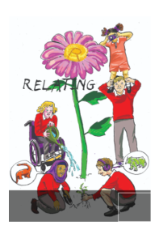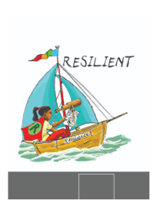School Council Minutes

Date: 07/05/25

Points

1. End of term KS2 vs KS2 competition

Ask classes what they would like:

Rugby, Netball, Hockey, Rounders – vote in class and let Ms Wells know the numbers.

1. Update school council board

Add our comments about school council – to be done next meeting.

1. Mr Brentnall - school hall – wording and vision

Linking learning heroes to sports:

Marcus Rashford playing football – responsible learning hero

Relating – any team sport

Resilient – shooting a basketball goal

Reflective – ?

Resourceful – rugby (as it’s hard to learn the rules)

1. Theme for the KS2 library

Discuss with classes. Look at catalogue for some big furniture. Big furniture – we like the circle but would like whatever can fit the most people in.

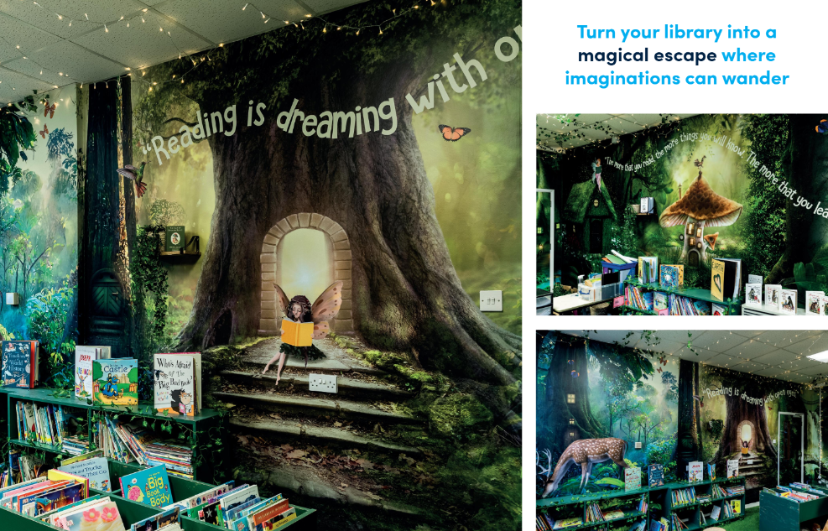

What else could we add? Ideas like quotes from animals eg Mouse – read quietly, Owl – read every night before bed, Fairy – reading takes you to magical places, Bat – lose yourself in a scary book. Discuss other ideas with your class eg quotes from books.

BEFORE THE NEXT MEETING, PLEASE DISCUSS WITH YOUR CLASS:

What end of term competition they would like – there will be four KS2 teams – one for each colour- competing against each other. The rest of the school can watch. Each team will be made up from 1 boy and 1 girl from each class and 1 child from Falcons.

What else can we add to the forest theme for the KS2 library.

Discuss any other ideas for the sports hall display.

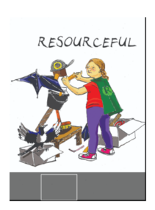Make notes in your school council book.

