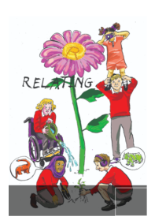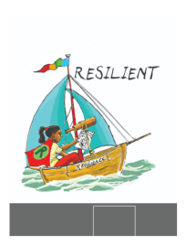School Council Minutes

Date: 21/05/25

Points

1. End of term KS2 vs KS2 competition

Feedback about what classes would like:

Rugby – 1 class (year 6)

Netball 2 classes (year 4 and 5)

Hockey 0 classes

Rounders – 2 classes and 4 adults voted for this

We will be doing ROUNDERS

1. Theme for the KS2 library

Ideas for Mr Brentnall:

Year 6 - Giant beanbag, chairs that look like trees, fluffy rugs, fake grass, a large hammock, bear teddies, a large teddy, put curtains over the computer, fairy lights, paint the walls dark green and black, dangling butterflies.

Woodpecker – peck away on a good book.

Year 4- Hang stars and a moon, tree with owls, tent, sign that says ‘make sure your read before bed every night’. An owl shaped arch.

Year 5 – fake mushrooms, fireflies, fairies, a floating bookshelf

Year 3 – ideas for quotes: Read before bed, use good expression, expand your reading mind, reading takes you places.

CS Lewis “The wood’s edge is where the wild begins.”

JRR Tolkein “The woods were wild and lovely and full of secret dangers.”

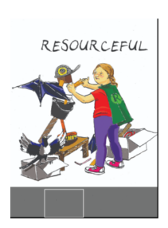Share the **rounders** competition with your class. Each class needs 8 children to take part ( a boy and a girl from each colour team).

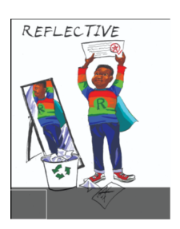Short meeting during assembly