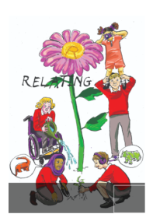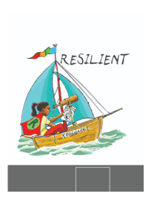School Council Minutes

Date: 06/10/25

Points

1. Meet and introduce

Introduce ourselves to each other.

Take pictures for new display.

1. Suggestions for school council impact for the year

Discuss what we would like to achieve over the next year.

OUTCOMES FROM THE MEETING

We would like to work on:

IMPROVING RECYCLING

A recycling bin in the playground that we could decorate

Compost bin for fruit snacks on the playground

Litter checks and litter pickers

BETTER PLAYTIME EQUIPMENT

Colouring

Better footballs/ more skipping ropes

Tables to sit on (KS2)

Scooters

IDEA BOX

FUN THINGS

Winter hunt at Christmas

Easter drawing competition and word search

Children versus children game - summer activity

BEFORE THE NEXT MEETING, PLEASE DISCUSS WITH YOUR CLASS:

Complete the survey about who feels happy and who feels safe? Please work out the % of the class for each part.

