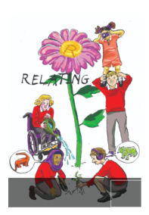
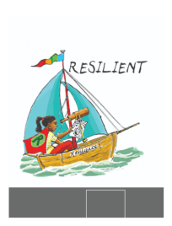
School Council Minutes

Date: 03/03/26
Points
- Easter activity
Decide on an end of spring term activity and create to share with classes.
- Red nose day ideas
Decide what will happen on Red nose day. School council to inform classes.
BEFORE THE NEXT MEETING, PLEASE DISCUSS WITH YOUR CLASS:
What will happen on Red Nose Day.
Make notes in your school council book.
